Glossary  
Google Business Intelligence Certificate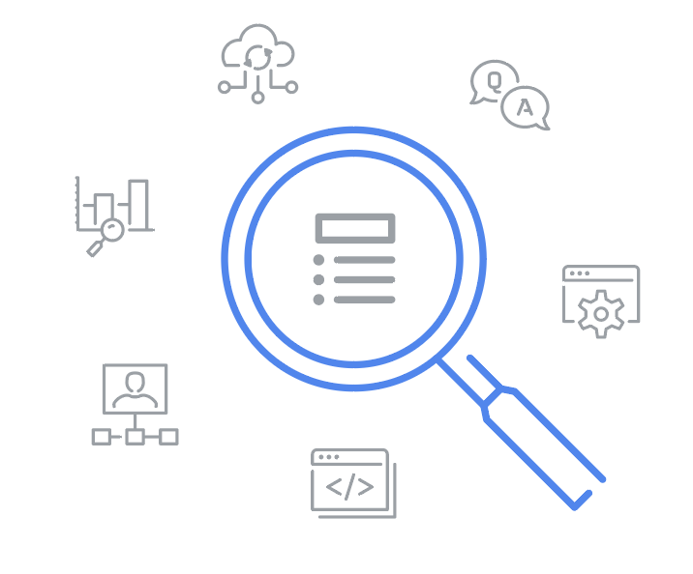

A

**Accuracy:** An element of quality testing used to confirm that data conforms to the actual entity being measured or described

**Application programming interface (API):** A set of functions and procedures that integrate computer programs, forming a connection that enables them to communicate

**Applications software developer:** A person who designs computer or mobile applications, generally for consumers

**Attribute:** In a dimensional model, a characteristic or quality used to describe a dimension

**Audience problem:** A dashboard issue caused by failing to adequately consider the needs of the user

B

**Business intelligence (BI):** Automating processes and information channels in order to transform relevant data into actionable insights that are easily available to decision-makers

**Business intelligence governance:** A process for defining and implementing business intelligence systems and frameworks within an organization

**Business intelligence monitoring:** Building and using hardware and software tools to easily and rapidly analyze data and enable stakeholders to make impactful business decisions

**Business intelligence stages:** The sequence of stages that determine both BI business value and organizational data maturity, which are capture, analyze, and monitor

**Business intelligence strategy:** The management of the people, processes, and tools used in the business intelligence process

**Business rule:** A statement that creates a restriction on specific parts of a database

C

**Columnar database:** A database organized by columns instead of rows

**Combined systems:** Database systems that store and analyze data in the same place

**Compiled programming language:** A programming language that compiles coded instructions that are executed directly by the target machine

**Completeness:** An element of quality testing used to confirm that data contains all desired components or measures

**Conformity:** An element of quality testing used to confirm that data fits the required destination format

**Contention:** When two or more components attempt to use a single resource in a conflicting way

**Consistency:** An element of quality testing used to confirm that data is compatible and in agreement across all systems

D

**Data analysts:** People who collect, transform, and organize data

**Data availability:** The degree or extent to which timely and relevant information is readily accessible and able to be put to use

**Data dictionary:** A collection of information that describes the content, format, and structure of data objects within a database, as well as their relationships

**Data governance professionals:** People who are responsible for the formal management of an organization’s data assets

**Data integrity:** The accuracy, completeness, consistency, and trustworthiness of data throughout its life cycle

**Data lake:** A database system that stores large amounts of raw data in its original format until it’s needed

**Data lineage:** The process of identifying the origin of data, where it has moved throughout the system, and how it has transformed over time

**Data mapping:** The process of matching fields from one data source to another

**Data mart:** A subject-oriented database that can be a subset of a larger data warehouse

**Data maturity:** The extent to which an organization is able to effectively use its data in order to extract actionable insights

**Data model:** A tool for organizing data elements and how they relate to one another

**Data partitioning:** The process of dividing a database into distinct, logical parts in order to improve query processing and increase manageability

**Data pipeline:** A series of processes that transports data from different sources to their final destination for storage and analysis

**Data problem:** A dashboard issue caused by the data being used

**Data visibility:** The degree or extent to which information can be identified, monitored, and integrated from disparate internal and external sources

**Data warehouse:** A specific type of database that consolidates data from multiple source systems for data consistency, accuracy, and efficient access

**Data warehousing specialists:** People who develop processes and procedures to effectively store and organize data

**Database migration:** Moving data from one source platform to another target database

**Database performance:** A measure of the workload that can be processed by a database, as well as associated costs

**Deliverable:** Any product, service, or result that must be achieved in order to complete a project

**Developer:** A person who uses programming languages to create, execute, test, and troubleshoot software applications

**Dimension (data modeling):** A piece of information that provides more detail and context regarding a fact

**Dimension (visualization):** A qualitative data type that can be used to categorize data

**Dimension table:** The table where the attributes of the dimensions of a fact are stored

**Design pattern:** A solution that uses relevant measures and facts to create a model in support of business needs

**Dimensional model:** A type of relational model that has been optimized to quickly retrieve data from a data warehouse

**Distributed database:** A collection of data systems distributed across multiple physical locations

E

**ELT (extract, load, and transform):** A type of data pipeline that enables data to be gathered from data lakes, loaded into a unified destination system, and transformed into a useful format

**Encoding:** The process of translating dimensions and measures into visual representations of the data

**ETL (extract, transform, and load):** A type of data pipeline that enables data to be gathered from source systems, converted into a useful format, and brought into a data warehouse or other unified destination system

**Experiential learning:** Understanding through doing

F

**Fact:** In a dimensional model, a measurement or metric

**Fact table:** A table that contains measurements or metrics related to a particular event

**Foreign key:** A field within a database table that is a primary key in another table (Refer to primary key)

**Fragmented data:** Data that is broken up into many pieces that are not stored together, often as a result of using the data frequently or creating, deleting, or modifying files

**Functional programming language:** A programming language modeled around functions

G

**Google DataFlow:** A serverless data-processing service that reads data from the source, transforms it, and writes it in the destination location

I

**Index:** An organizational tag used to quickly locate data within a database system

**Information technology professionals:** People who test, install, repair, upgrade, and maintain hardware and software solutions

**Integrity:** An element of quality testing used to confirm that data is accurate, complete, consistent, and trustworthy throughout its life cycle

**Interpreted programming language:** A programming language that uses an interpreter, typically another program, to read and execute coded instructions

**Iteration:** Repeating a procedure over and over again in order to keep getting closer to the desired result

K

**Key performance indicator (KPI):** A quantifiable value, closely linked to business strategy, which is used to track progress toward a goal

L

**Logical data modeling:** Representing different tables in the physical data model

**Low-fidelity mockup:** A simple draft of a visualization that is used for planning a dashboard and evaluating its progress

M

**Measure:** A quantitative data type that can be either discrete or continuous

**Metric:** A single, quantifiable data point that is used to evaluate performance

O

**Object-oriented programming language:** A programming language modeled around data objects

**Object-level permission:** A privacy setting that controls the availability of a single item in a dashboard

**OLAP (Online Analytical Processing) system:** A tool that has been optimized for analysis in addition to processing and can analyze data from multiple databases

**OLTP (Online Transaction Processing) database:** A type of database that has been optimized for data processing instead of analysis

**Optimization:** Maximizing the speed and efficiency with which data is retrieved in order to ensure high levels of database performance

P

**Portfolio:** A collection of materials that can be shared with potential employers

**Pre-aggregation:** The process of performing calculations on data while it is still in the database

**Primary key:** An identifier in a database that references a column or a group of columns in which each row uniquely identifies each record in the table (Refer to foreign key)

**Processing speed:** How quickly a program can update and load a specified amount of data

**Project manager:** A person who handles a project’s day-to-day steps, scope, schedule, budget, and resources

**Project sponsor:** A person who has overall accountability for a project and establishes the criteria for its success

**Public availability:** A privacy setting that allows anyone to access a dashboard

**Python:** A general purpose programming language

Q

**Quality testing:** The process of checking data for defects in order to prevent system failures; it involves the seven validation elements of completeness, consistency, conformity, accuracy, redundancy, integrity, and timeliness

**Query plan:** A description of the steps a database system takes in order to execute a query

R

**Redundancy:** An element of quality testing used to confirm that no more data than necessary is moved, transformed, or stored

**Resources:** The hardware and software tools available for use in a database system

**Response time:** The time it takes for a database to complete a user request

**Row-based database:** A database that is organized by rows

**Row-level permission:** A privacy setting that controls the availability of specific rows of a table or dataset in a dashboard

S

**Schema validation:** A process to ensure that the source system data schema matches the target database data schema

**Separated storage and computing systems:** Databases where data is stored remotely, and relevant data is stored locally for analysis

**Single-homed database:** Database where all of the data is stored in the same physical location

**Snowflake schema:** An extension of a star schema with additional dimensions and, often, subdimensions

**Star schema:** A schema consisting of one fact table that references any number of dimension tables

**Strategy:** A plan for achieving a goal or arriving at a desired future state

**Subject-oriented:** Associated with specific areas or departments of a business

**Systems analyst:** A person who identifies ways to design, implement, and advance information systems in order to ensure that they help make it possible to achieve business goals

**Systems software developer:** A person who develops applications and programs for the backend processing systems used in organizations

T

**Tactic:** A method used to enable an accomplishment

**Target table:** The predetermined location where pipeline data is sent in order to be acted on

**Throughput:** The overall capability of the database’s hardware and software to process requests

**Timeliness:** An element of quality testing used to confirm that data is current

**Tool problem:** A dashboard issue involving the hardware or software being used

**Trade-off:** Balancing various factors, often by prioritizing one element while sacrificing another, in order to arrive at the best possible result

**Transferable skill:** A capability or proficiency that can be applied from one job to another

V

**Vanity metric:** Data points that are intended to impress others, but are not indicative of actual performance and, therefore, cannot reveal any meaningful business insights

W

**Workload:** The combination of transactions, queries, data warehousing analysis, and system commands being processed by the database system at any given time